**ASSIGNMENT 1**

**Defining & Solving RL Environments**

**1)Describe the deterministic and stochastic environments, which were defined (set of actions/states/rewards, main objective, etc).**

Deterministic Environment:

The deterministic environment models a warehouse robot that follows a grid-world structure with fixed movement rules and obstacles. The environment operates with the following characteristics:

States: The state space is defined by the robot's position (x, y) and whether it is carrying an item (binary variable: 0 or 1).

Actions: The agent has 6 discrete actions:

* 1. Move Up
  2. Move Down
  3. Move Left
  4. Move Right
  5. Pick-up the package (if at the item's position)
  6. Drop-off the package (if at the drop-off location)

Obstacles: The grid contains static obstacles that block movement.

Rewards:

-1 per step (encouraging efficiency)

-20 penalty for hitting an obstacle

+25 reward for picking up the item

+100 reward for successfully dropping off the item

Main Objective: The agent must navigate from the start position, pick up an item at a fixed location, and drop it off at another fixed location while avoiding obstacles. The optimal policy is to minimize steps and avoid obstacles.

Stochastic Environment (Stochastic_warehouse Class)

The stochastic version introduces randomness in the agent’s movement and dynamic obstacles, making navigation more unpredictable.

States: Similar to the deterministic environment: robot position (x, y) and whether it's carrying an item.

Actions: The same 6 discrete actions as before.

Stochastic Behavior:

With 10% probability, the robot's movement fails, meaning the intended action may not execute.

This introduces uncertainty, making planning more challenging.

Rewards:

Similar reward structure as in the deterministic environment.

However, because of stochastic movement, the agent may receive penalties unintentionally.

Main Objective: The goal remains the same (pick up and drop off an item), but due to random failures and moving obstacles, the agent must adapt its policy to account for unexpected setbacks.

**2) Provide visualizations of your environments.**

Deterministic environment:

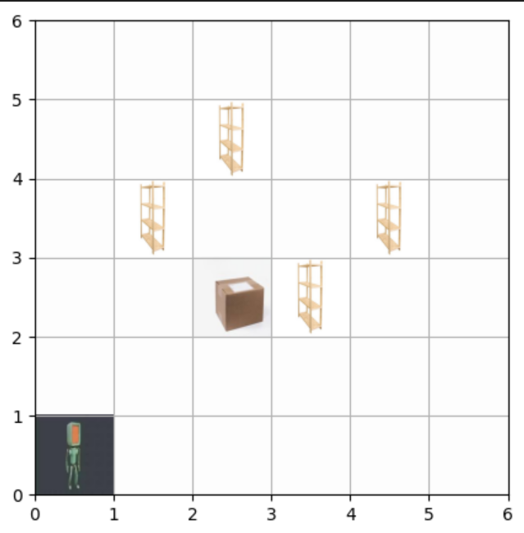

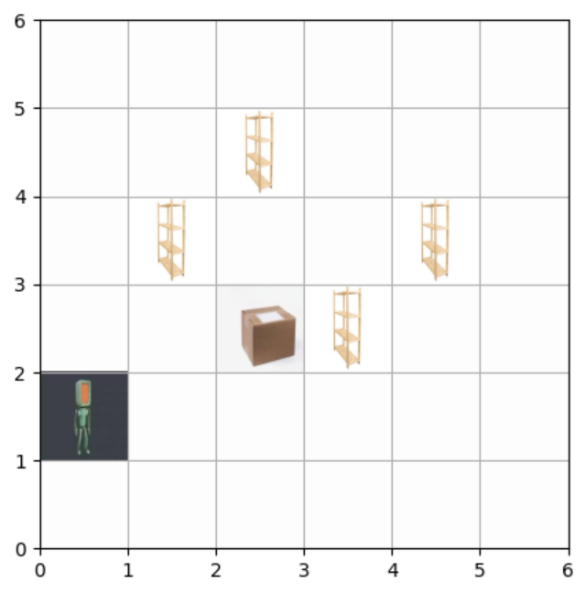

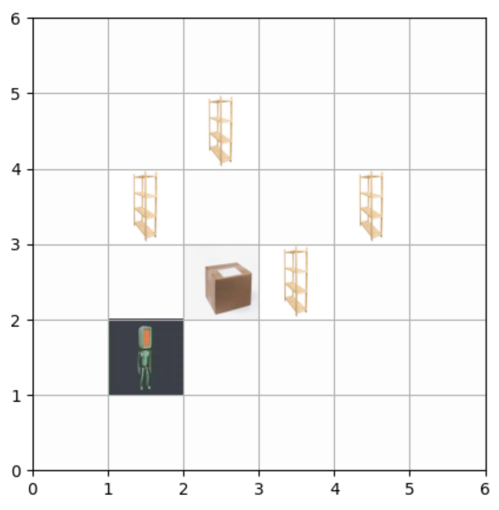

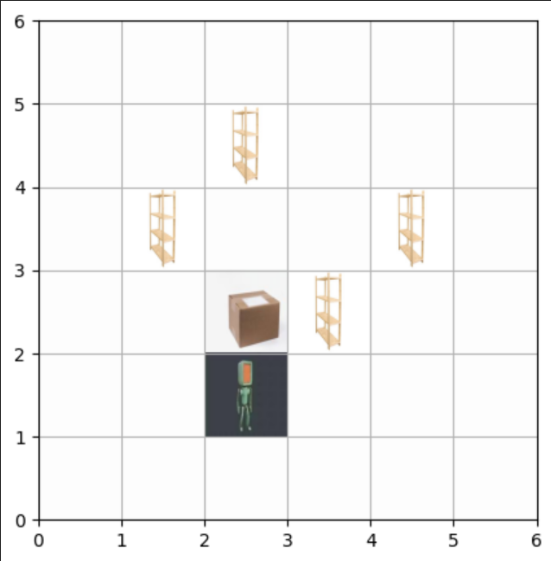

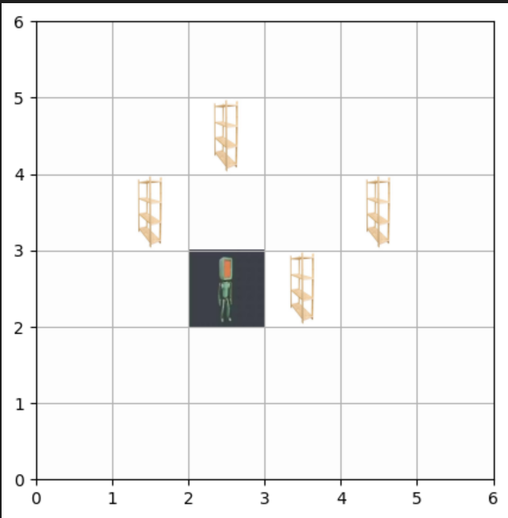

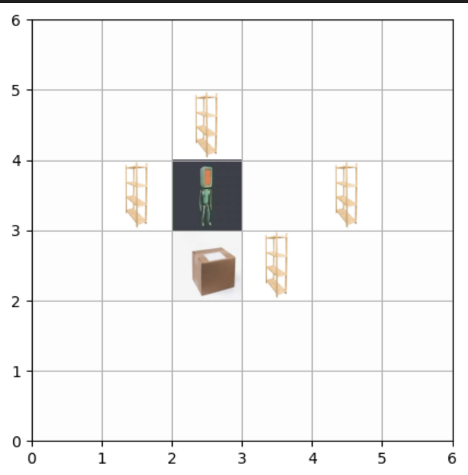

**STOCHASTIC ENVIRONMENT:**

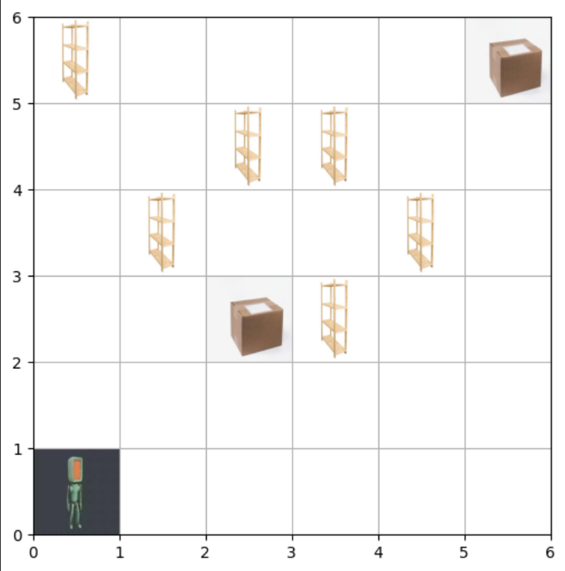

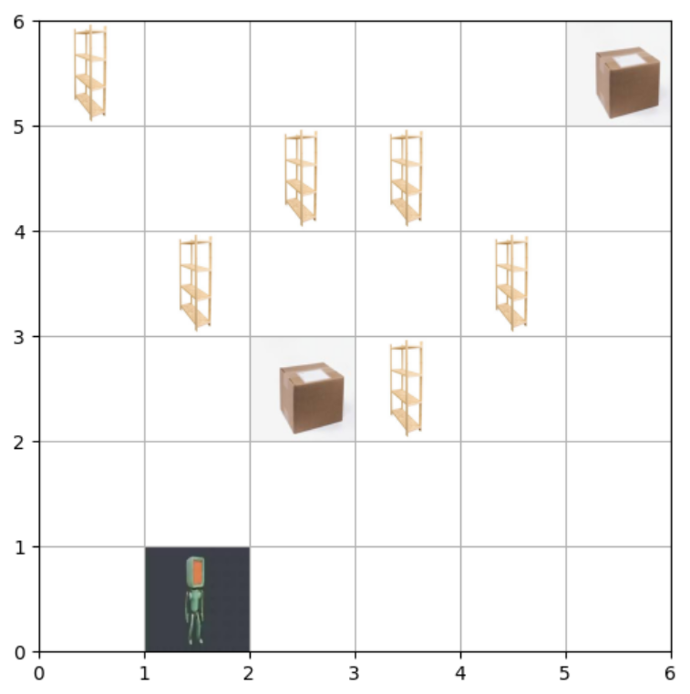

I have provided different pictures of my environment above.

**3) How did you define the stochastic environment?**

The stochastic environment was defined by introducing randomness in movement and dynamic obstacles to make navigation less predictable. The key modifications from the deterministic environment include:

Stochastic Movement:

With a 10% probability, the agent's movement fails, meaning the intended action does not execute.

This simulates real-world uncertainty, such as slipping, sensor errors, or mechanical failures.

State Representation:

The state still consists of the robot’s position (x, y) and whether it is carrying an item (0 or 1).

1. Action Set (Same as Deterministic Environment):

6 discrete actions: Up, Down, Left, Right, Pick-up, Drop-off.

1. Reward Structure (Same as Deterministic Environment):

-1 per step (to encourage efficiency).

-20 penalty for colliding with obstacles.

+25 reward for successfully picking up the item.

+100 reward for successfully dropping off the item.

**4) What is the difference between the deterministic and stochastic environments**

Differences:

**Deterministic Environment:**

1) The agent's actions always lead to the expected outcome.  
2) Fixed obstacles remain in the same position throughout.  
3) No randomness in movement or state transitions.  
4) The agent can follow a fixed optimal path.  
5) Predictable environment, making it easier to solve.

**Stochastic Environment:**

1) 10% chance of movement failure, adding randomness.  
2) Includes dynamic obstacles that change positions over time.  
3) The agent may not always move as expected, requiring adaptability.  
4) The same action may lead to different outcomes in different runs.  
5) More realistic and challenging, requiring flexible strategies.

**5) Safety in AI: Write a brief review (∼ 5 sentences) explaining how you ensure the safety of your environments. E.g. how do you ensure that agent choose only actions that are allowed, that agent is navigating within defined state-space, etc**

Ensuring safety in AI environments involves setting strict constraints on the agent’s actions and state transitions. The environment defines a finite grid with clear boundaries, preventing the agent from moving outside the allowed space. Actions that would lead to invalid states (e.g., moving into obstacles) are handled by reverting the agent's position and applying a negative reward to discourage such behavior. Additionally, in the stochastic environment, randomness is controlled to ensure that transitions remain within safe limits while still introducing uncertainty. By implementing these safeguards, the agent learns to navigate efficiently while avoiding unsafe or undefined behaviors.

Github link: <https://github.com/shishirhebbar1/RL_assignment1>

Github commits snapshot:



**PART 2:**

**1)Show and discuss the results after**

**a) Applying Q-learning to solve the deterministic environment defined in Part 1. Plots should include epsilon decay and total reward per episode.**

Final Q table values:  
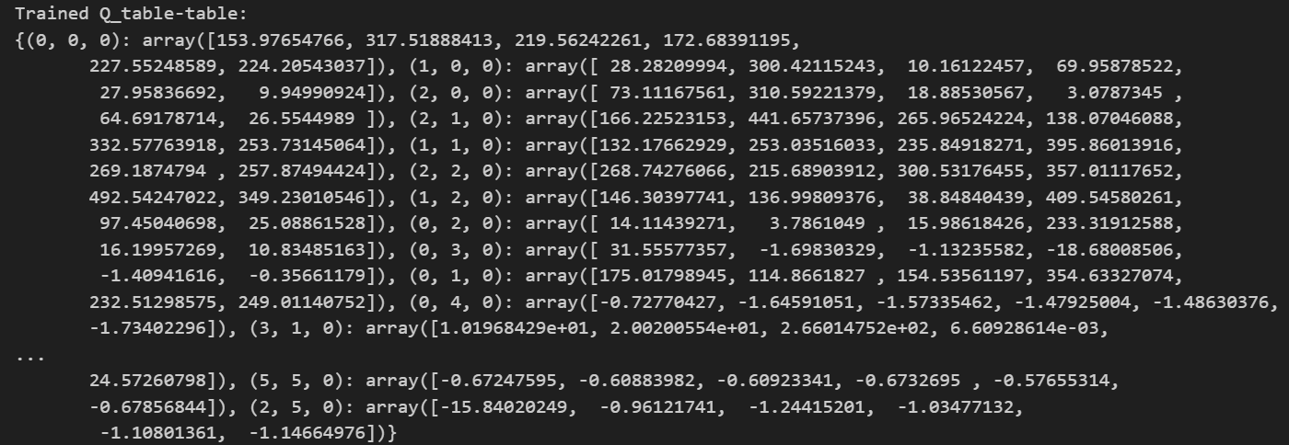  
Q learning performance(Total reward pre episode):  
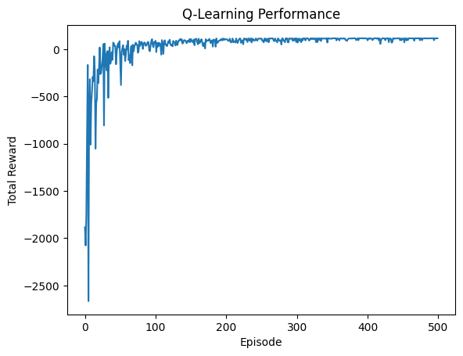

The graph shows the total reward per episode during Q-learning training, starting with poor performance as the agent explores randomly, leading to low rewards (even around -2500). As training progresses, the agent improves its decision-making, resulting in a steady increase in rewards. By around 100-200 episodes, fluctuations decrease, indicating learning convergence. After 200-300 episodes, the rewards stabilize near an optimal value, suggesting the agent has developed an effective policy. The overall trend reflects successful learning, with early exploration giving way to refined exploitation, though some noise remains due to continued exploration or environmental variability.

Epsilon decay:  
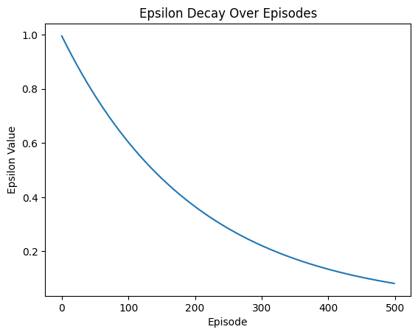

The graph illustrates the epsilon decay over episodes, showing how the exploration rate decreases as training progresses. Initially, epsilon starts at 1.0, meaning the agent explores actions randomly. As episodes advance, epsilon decays exponentially, reducing the randomness in action selection and encouraging exploitation of learned policies. By the later episodes, epsilon approaches its minimum value, ensuring the agent relies more on its learned Q-values rather than random exploration. This controlled decay balances exploration and exploitation, allowing the agent to learn an optimal strategy while avoiding premature convergence to suboptimal policies.

Greedy policy performance(Total rewards per episode):  
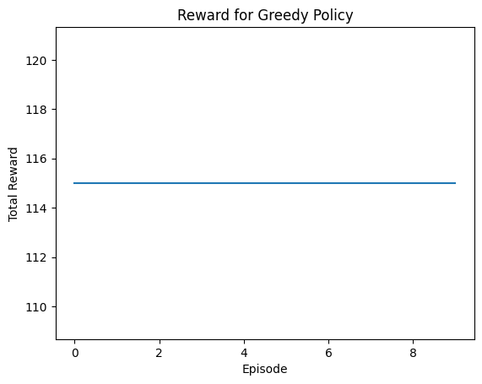  
The graph represents the total reward over episodes when following a greedy policy, where the agent always selects the action with the highest Q-value. The flat line suggests that the total reward remains constant across episodes, indicating a stable and deterministic policy. This could mean the agent has fully converged to an optimal strategy, consistently achieving the same reward in each episode. However, if variability was expected, this could also indicate a lack of dynamic adaptation or a limitation in the environment's reward structure.

**b) Applying Q-learning to solve the stochastic environment defined in Part 1. Plots should include epsilon decay and total reward per episode.**

Q-table values:  
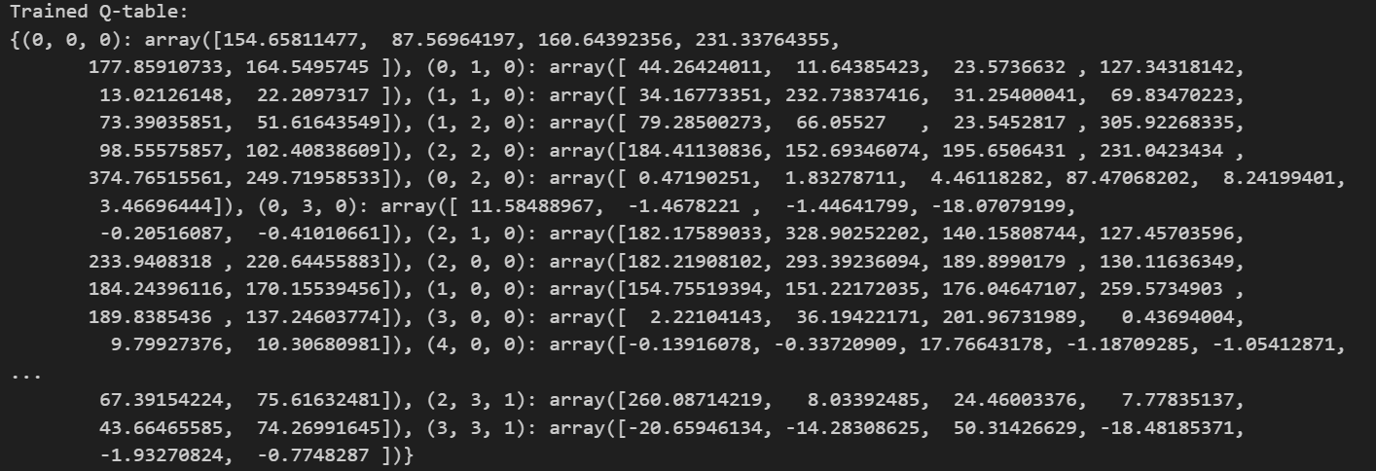

Q learning performance(Total reward pre episode):  
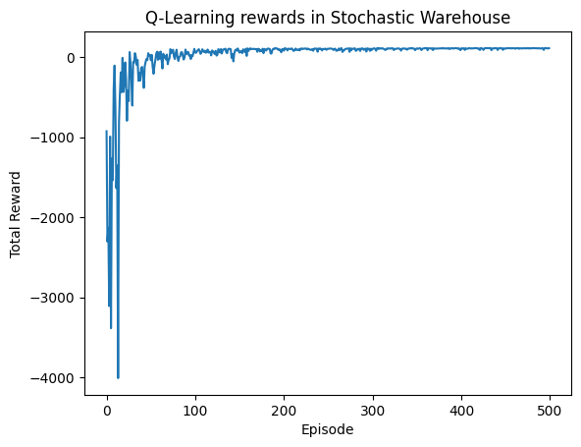

The Q-learning reward curve in the stochastic warehouse environment shows an initial phase of high variance and low rewards, indicating exploration and suboptimal decisions. Within the first 50 episodes, the rewards improve sharply as the agent learns better policies. By around 100 episodes, the learning stabilizes, and after 200 episodes, the rewards remain nearly constant, suggesting convergence to an optimal or near-optimal policy. Despite the stochastic nature of the environment, Q-learning successfully adapts, demonstrating its effectiveness in handling randomness. The final stability of the curve indicates a well-learned policy with minimal variance.

Epsilon decay:  


The graph illustrates the epsilon decay over episodes in a Q-learning setup, where epsilon starts at 1.0 and gradually decreases as training progresses. Initially, a high epsilon encourages exploration, allowing the agent to try various actions. As episodes increase, epsilon decays exponentially, reducing exploration in favor of exploitation, enabling the agent to rely on learned policies. By around 500 episodes, epsilon is close to zero, meaning the agent predominantly exploits the optimal policy. This decay strategy balances exploration and exploitation, ensuring efficient learning while avoiding premature convergence to suboptimal policies.